**PROJECT REPORT**

**Code-RCA-552**

**ON**

**Lab Attendance**

**Submitted towards Partial Fulfillment for the Requirements of 5thSemester of**

**MASTER OF COMPUTER APPLICATION**

**Submitted By**

**Vikram Burman : 1703614959**

**Supervised by**

**Mr. Avneesh Vashistha**



**Department of Computer Application**

**Institute of Management Studies, Ghaziabad**

**Dr. A.P.J. Abdul Kalam Technical University**

**Lucknow, Uttar Pradesh**

**SESSION: 2018-2019**



**PROJECT ACCEPTANCE CERTIFICATE**

This is to certify that project work entitled **“Lab Attendance”** by **Vikram Burman,** student of 5**th Semester in Master of compute APPLICATION batch MCA-le 2017-19** of **INSTITUTE OF MANAGEMENT STUDIES, GHAZIABAD affiliated** to **Dr. A.P.J ABDUL KALAM TECHNICAL university, LUCKNOW,** hereby accepted for the partial fulfillment of **MASTER OF COMPUTER APPLICATION.**

**Mr. Avneesh Vashistha**

**Project Supervisor**

**DECLARATION**

I **Vikram Burman,** do hereby declare that the project work entitled **Lab Attenndance** is an authenticated work carried out by me under the guidance of  **Mr. Aravendra Sharma** for the partial fulfillment of **MASTER of Computer APPLICATION** and this work has not been submitted for similar purpose anywhere else except to **INSTITUTE OF MANAGEMENT STUDIES GHAZIABAD**, affiliated to **Dr. A.P.J. ABDUL KALAM technical university, LUCKNOW.**

**Student Name : University Roll Number**

**Vikram Burman : 1703614959**

**ACKNOWLEDGEMENT**

I would like to express my sincere gratitude to my supervisor**, Mr. Avneesh Vashistha**,for proper supervision and timely support. His wide knowledge, guidance and continuous encouragements have been a great help throughout our project work.

I would like to thank Dr. Sachin Malhotra (Dean-MCA), **Mr. Avneesh Vashistha** and all faculty members of ***Department of Computer Application, Institute of Management Studies, Ghaziabad*** who have given valuable guidelines and suggestions for completion of my project, and also motivated me throughout entire project.

**Student Name : University Roll Number**

**Vikram Burman : 1703614959**

**TABLE OF CONTENTS**

**Page no.**

**Chapter 1.Introduction**

* 1. **Introduction 6**
  2. **Objective 7**
  3. **Theoretical Background 8**

**Chapter 2.Feasibility Study 9**

**Chapter 3.Software Requirement Specifications**

* 1. **Software Requirements 9**
  2. **Hardware Requirements 9**

**Chapter 4.Design**

* 1. **ER Diagram 10**

**Chapter 5.Testing& Implementation 11-12**

**Chapter 6.Conclusion and Future Scope 13**

**Appendices**

1. **Input /Output Forms 14-19**
2. **Coding 20-78**

**References 79**

**INTRODUCTION**

The project titled “**Lab Attendance”** is Lab management software for monitoring and controlling the management in a lab. This project is designed and coded in **Java Swing** and database management is handled by **MYSQL**. This software mainly focuses on basic operations in a library like **Admin Login, Add Pc Info**, **Assign Pc to Student**, **View Detail according to Pc**, and **Search and view Student with Attendance or using Pc Info**. **“Lab Attendance “**is a java application written on 64 bit, Window 8.1 operating system, designed to help users maintain and organize lab. This software is easy to use for both beginners and advanced users. It features a familiar and well thought out an attractive user interface, combined with strong searching insertion and reporting capabilities. The report generation facility of lab system helps to get a good idea of which are the system issued or returned by the members.

**This software has five main modules**:

Admin Login – Admin Friendly login screen

Add Pc Info – User friendly input screen.

Assign Pc to Student – Attractive Student Pc Assign screen.

View Detail According to Pc – Attractive Output Screen.

Search and view student with attendance or using info– Search for Student and Pc Data.

**OBJECTIVE**

To assist and easy the works of educational organizations, in particular, in Lab Attendance system is being developed. This would comprise the features that can be operated easily. Lab Attendance system would take care of the day to day records of all lab Activities. It covers activities from keeping the details of their issue date, deposit dates etc.

The final records are shown in data reports so that the activities can be operated easily.

So, the Lab Attendance systems assist the lab attendance of organizations in each and every aspect of in and out.

The lab attendance system is customized software and developed according to the needs of any type educational organizations.

**Features**

Manage the Pc info Student info in the lab.

Data reports

Easily maintainable and updateable

One software deals with multi- organizations lab attendance records management

Easy to handle

And lastly secured and reliable

**BACK END OF PROJECT**

DBMS is stands for data base management system. It is the set of program to use or modified the data. A DBMS is a software Package design to define, change, retrieve, and manage data in data base.

MySQL is a fast, easy to use RDBMS being used for many small and big businesses. MySQL is developed, marketed, and supported by MSQL AB, which is Swedish company. MYSQL is becoming so popular because of many good reasons:

MYSQL is very powerful program in its own right. It handles a large subset of the functionality of the most expensive and powerful database packages.

MYSQL uses a standard form of the well known SQL data language.

MYSQL works on many operating systems and with many languages including PHP, PERL, C, C++, JAVA, etc.

MYSQL works very quickly and works well even with large data sets.

MYSQL is very friendly to PHP, the most appreciated language for web development.

MYSQL supports large database, up to 50 million rows or more in a table. The default file size limit for a table is 4 GB, but you can increase this to a theoretical limit of 8 million terabytes (TB).

MYSQL is released under an open source license. So you have nothing to pay to use it

**REQUIREMENTS AND ANALYSIS**

The Lab Attendance Systems shall be required to maintain information about its users and also will help to give the whole detail of that user .

It shall store database for students, and Computer Systems.

The student’s database stores information about a student id, student name, and course pc issued information and more.

The System’s database stores information about a computer system, like Ram, Rom , Harddisk, and more.

**HARDWARE REQUIRMENTS*:***

Processor                     :           Pentium 2.4 GHz or above

Memory                       :           512 MB RAM or above

Cache Memory            :           128 KB or above

**SOFTWARE REQUIRMENTS*:***

Operating System     :       Windows 7 and above

Front-End Tool          :        Java Programming

Back-End                   :       MySQL

***E-R DIAGRAM OF LAB SYSTEM***

LAB

WorkStations

ISSUE

CONTAINS

Students

**Testing**

Testing is a very critical activity that ensure the liability of a particular software product. During this activity the software to be tested is executed with a set of tests, and the output and functioning of the program are evaluated. It is done to ensure whether the system meets the specified requirement or not.

Testing can bring forth some aspects that have not been considered or covered by the developers. Testing a large program is a complex process that can be broken down into two parts:

* Unit Testing
* System Testing

In the first case of different modules of the application are tested individually. In case of system testing the software is tested as a whole. The system undergoes several tests like:

* Time tests
* Performance tests
* Memory tests
* Input and Output tests, etc.

Testing can be done in the following three phases:

* **Programmatic testing –** This is done to determine whether the application works according to the specifications. Here it is checked whether the application is providing all the required functionalities and features or not . All the validations are checked thoroughly. All the links are tested and the database functionalities are also checked.
* **User testing –** In this phase it is ascertained whether the target audience for the application can use the application easily an effectively. Is the software system is serving their purpose and fits their requirement or not .It is checked whether they are satisfied with the information provided. They are asked about the clarity, attractiveness and the overall presentation of the screen and reports.
* **Goal testing –** Finally this test is performed to test whether the application meets the goals, which were set before developing the application . Here it must be ensured that the organization is satisfied with the working and presentation of the application.

**SYSTEM SECURITY**

**System security** is responsible for controlling access to system resources, which will include sensitive data. The system must therefore include a certain amount of protection for such data, and must in turn control access to those parts of the system that administer this protection. In our system a good care has been taken for data security. The administrator has the control for all serious activities such as adding member, book issue, and book details. No user can delete the data without the permission of administrator. For users also there is id and password for accessing the account. So in this way the system is very much secured*.*

***PHYSICAL SECURITY:***

Physical security is often overlooked and its importance underestimated. In favor of more technical threats such as hacking, malware. However, breaches of physical security can be carried out with brute force and little or no technical knowledge on the part of an attacker.

Physical security has three important components*:*

* Access control
* Surveillance
* Testing

**Future Scope**

* This project has many features application like it can be used in any type of Computer Labe System.
* This project was build keeping in mind the major requirements of educational institution and they can be implemented in any such type of organization with very few modification.
* With modifications it can be possible for computer records to control organization by connecting them through a network. Because of this software all they need is a server application and any type of connectivity to that server.

**LOGIN TABLE**

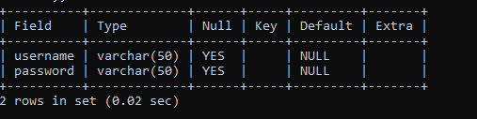

**Assign pc**

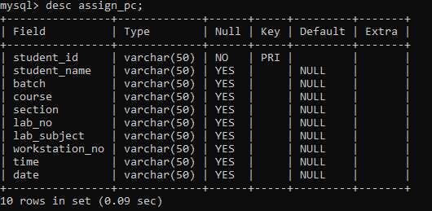

**Pc Info**

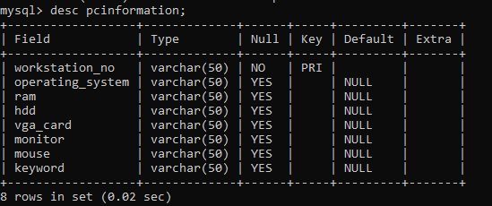

**Welcome To Lab Attendance System**

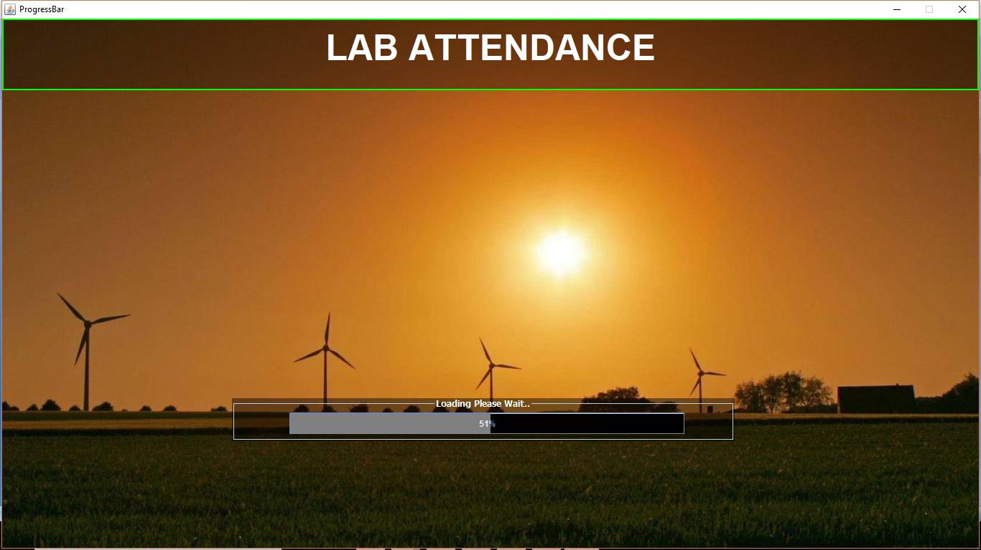

**Admin Login Form**

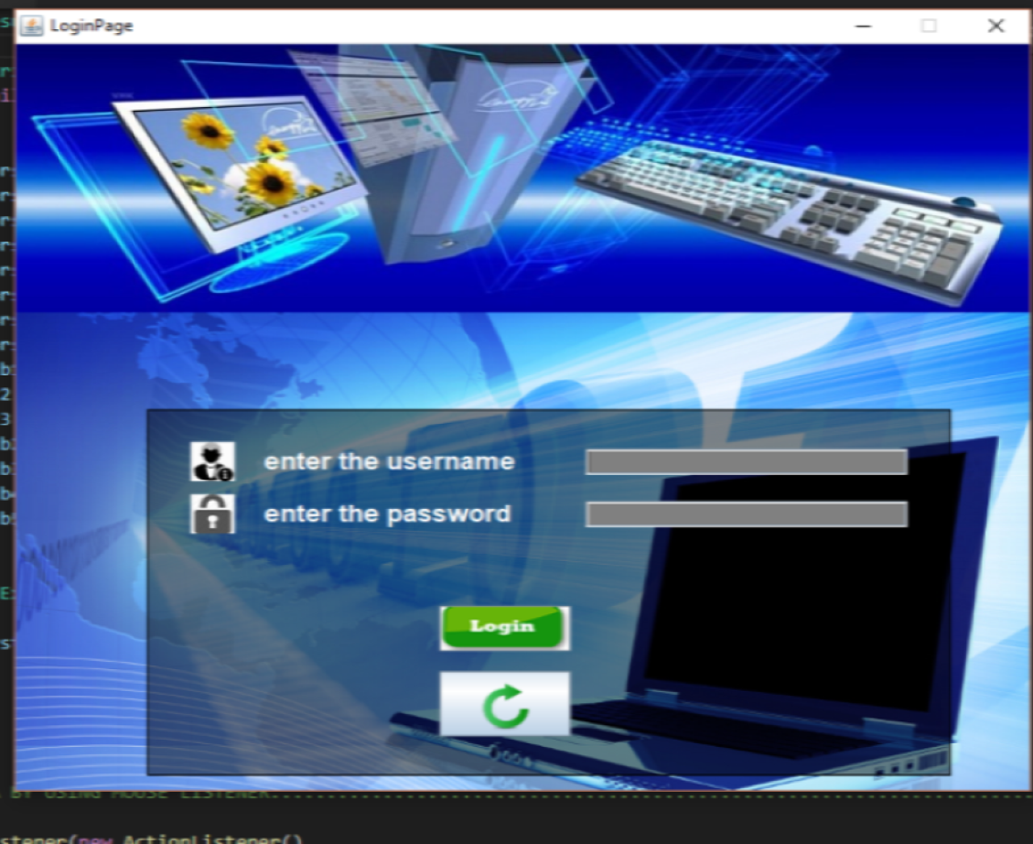

**Working Module**

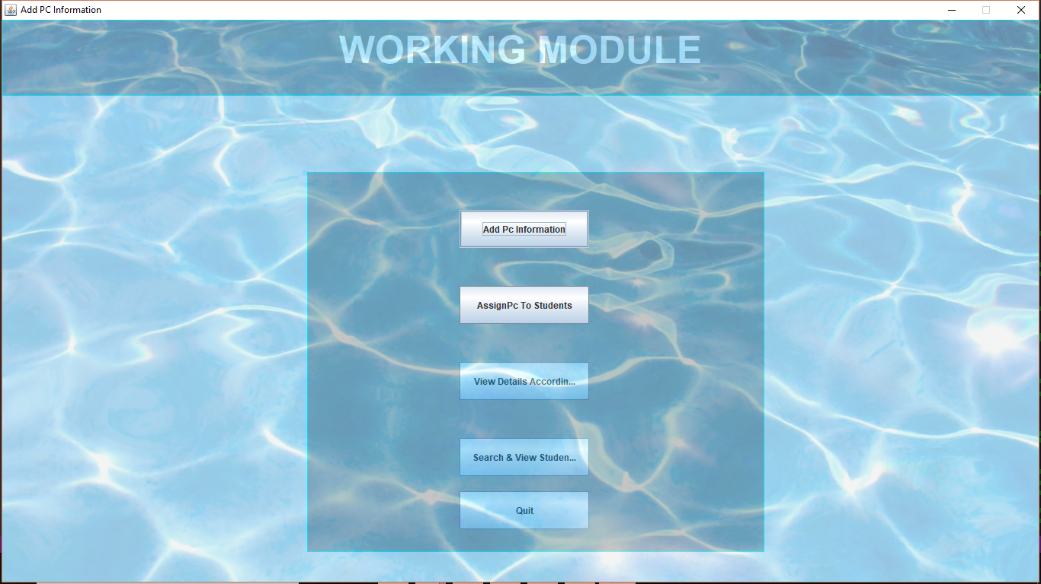

**Add Pc Info**

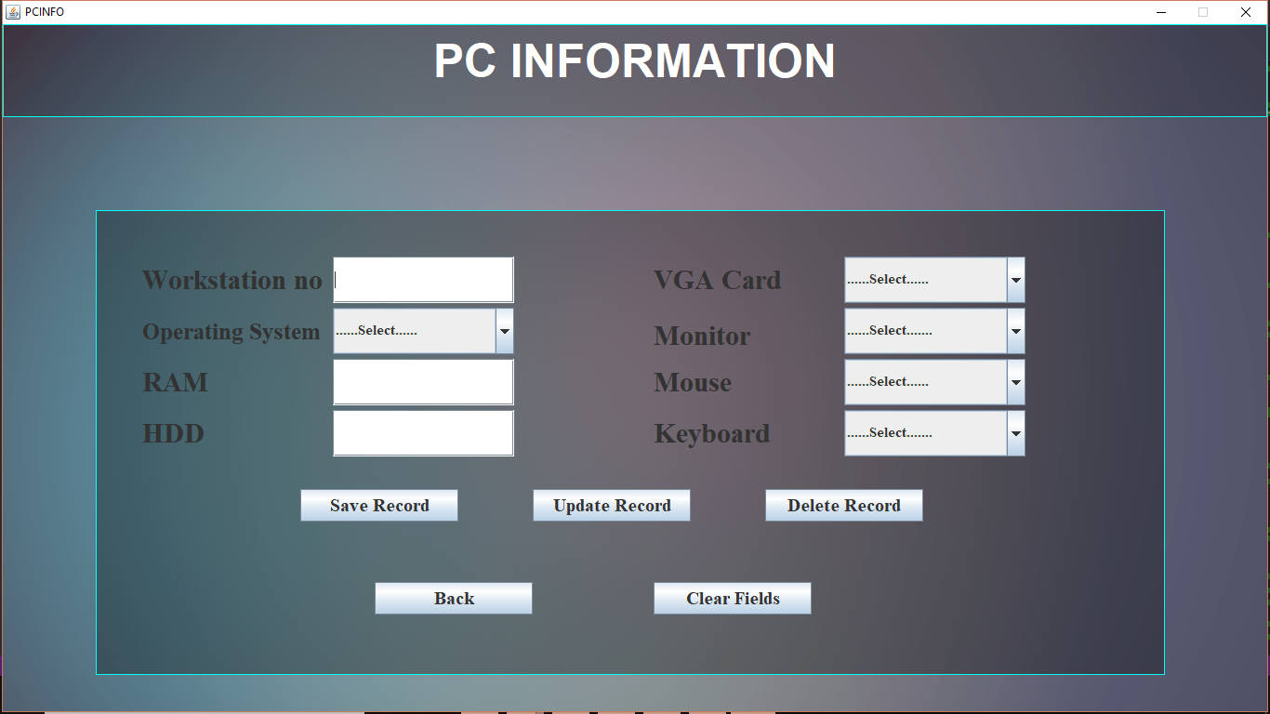

**Assign Pc to Student**

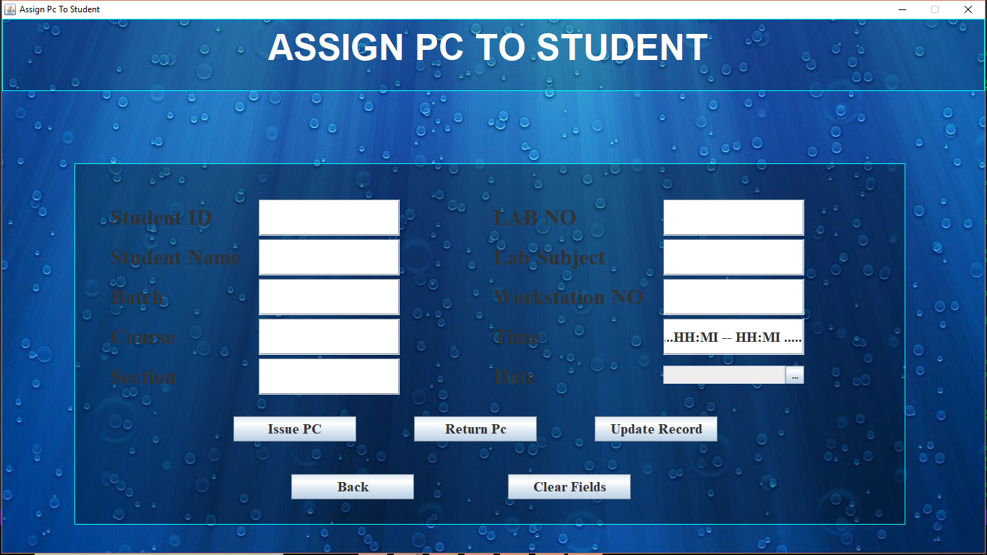

**Add view Details**

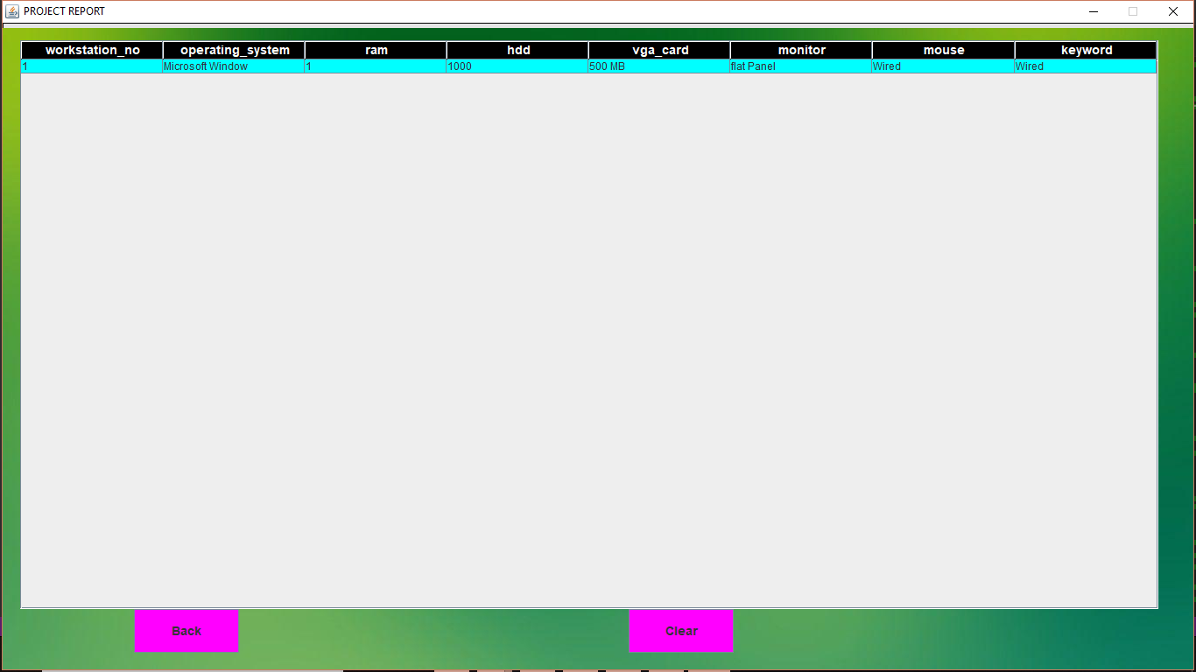

**View Student with Attendance**

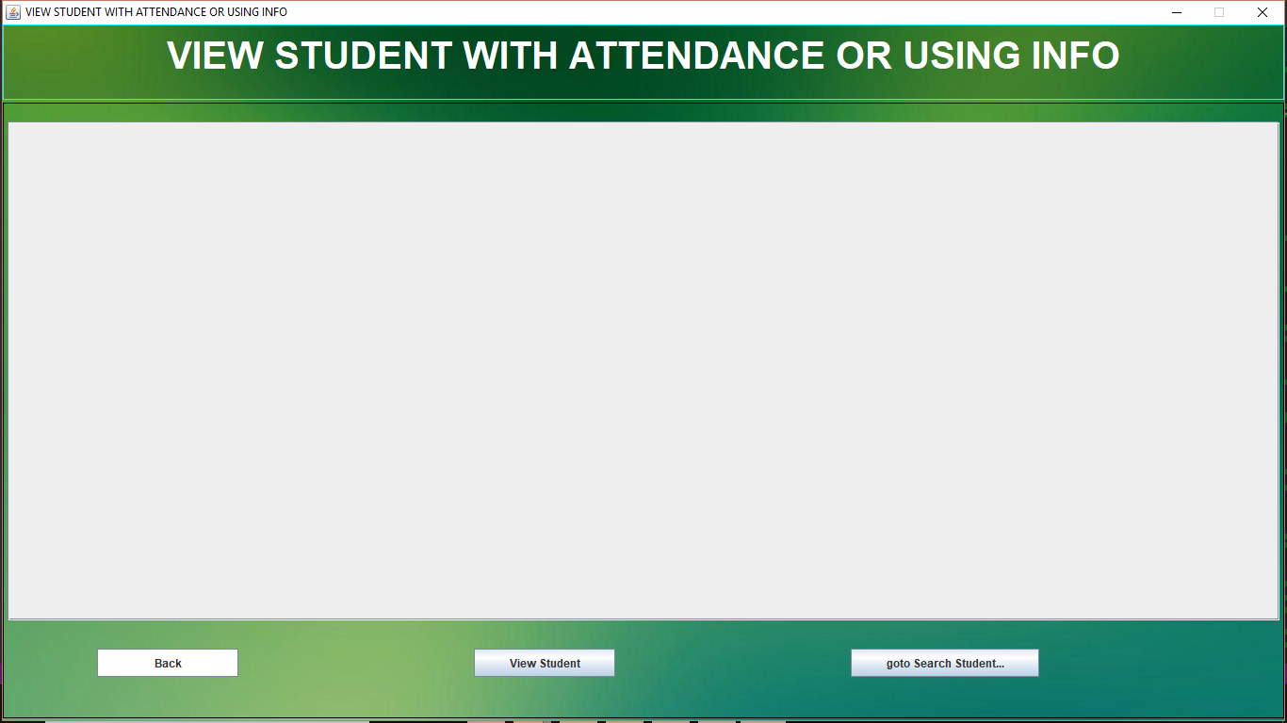

**About**

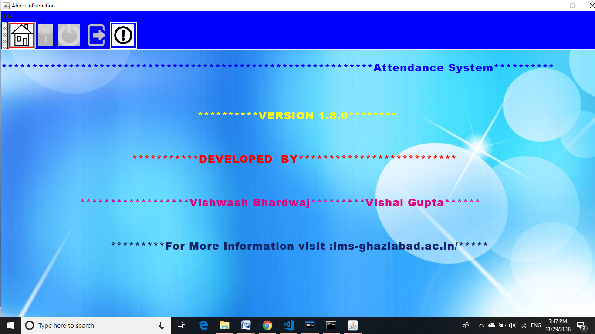

**Coding:**

import java.util.*;

import javax.swing.*;

import java.awt.*;

import java.awt.event.*;

import java.sql.*;

import java.applet.*;

import java.net.*;

import net.proteanit.sql.DbUtils;

import javax.swing.table.*;

import java.util.Calendar;

import java.util.Date;

import org.jdatepicker.impl.*;

import org.jdatepicker.util.*;

import org.jdatepicker.*;

import org.jdatepicker.graphics.*;

import java.text.*;

import javax.swing.JFormattedTextField.AbstractFormatter;

//CODE FOR ADD PC INFORMATION

class pcinfo

{

JFrame jf;

JLabel jl1,jl2,jl3,jl4,jl5,jl6,jl7,jl8,jl9,jl10;

JTextField jt1,jt2,jt3,jt4,jt5,jt6,jt7;

JComboBox jcb1,jcb2,jcb3,jcb4,jcb5;

JButton jb1,jb2,jb3,jb4,jb5;

Dimension ds;

ImageIcon ic;

JPanel jp1,jp2;

AudioClip clip;

URL ur;

pcinfo()

{

jf=new JFrame("PCINFO");

ic=new ImageIcon(this.getClass().getResource("/b.png"));

jl1=new JLabel(ic);

jf.setLayout(null);

jf.setDefaultCloseOperation(jf.DO_NOTHING_ON_CLOSE);

ds=Toolkit.getDefaultToolkit().getScreenSize();

jf.setSize(ds.width,ds.height);

jl1.setSize(ds.width,ds.height);

Font f = new Font(" Ravie" , Font.BOLD, 50);

jp1=new JPanel();

jp1.setBounds(0,0,1360,100);

jp1.setBackground(new Color(0,0,0,48));

jp1.setBorder(BorderFactory.createTitledBorder(BorderFactory.createLineBorder(Color.cyan,1),""));

jl2 = new JLabel("PC INFORMATION");

jl2.setForeground(Color.WHITE);

jl2.setFont(f);

ur=pcinfo.class.getResource("wr.wav");

clip=Applet.newAudioClip(ur);

jp2=new JPanel();

jp2.setLayout(null);

jp2.setBackground(new Color(0,0,0,80));

jp2.setBounds(100,200,1150,500);

jp2.setBorder(BorderFactory.createTitledBorder(BorderFactory.createLineBorder(Color.cyan,1),""));

Font f1= new Font("Times New Roman",Font.BOLD,30);

jl3=new JLabel("Workstation no");

jl3.setBounds(50,50,195,50);

jl3.setFont(f1);

jl4=new JLabel("Operating System");

jl4.setBounds(50,105,195,50);

Font font=new Font("Times New Roman",Font.BOLD,25);

jl4.setFont(font);

jl5=new JLabel("RAM");

jl5.setBounds(50,160,195,50);

jl5.setFont(f1);

jl6=new JLabel("HDD");

jl6.setBounds(50,215,195,50);

jl6.setFont(f1);

jl7=new JLabel("VGA Card");

jl7.setBounds(600,50,195,50);

jl7.setFont(f1);

jl8=new JLabel("Monitor");

jl8.setBounds(600,110,195,50);

jl8.setFont(f1);

jl9=new JLabel("Mouse");

jl9.setBounds(600,160,195,50);

jl9.setFont(f1);

jl10=new JLabel("Keyboard");

jl10.setBounds(600,215,195,50);

jl10.setFont(f1);

Font fo=new Font("Times New Roman",Font.BOLD,15);

jt1=new JTextField();

jt1.setBounds(255,50,195,50);

jt1.setFont(fo);

jcb1=new JComboBox();

jcb1.setBounds(255,105,195,50);

jcb1.setFont(fo);

jcb1.addItem("......Select......");

jcb1.addItem("Microsoft Window");

jcb1.addItem("Linux");

jcb1.addItem("Mac Os");

jcb1.addItem("IOS");

jt2=new JTextField();

jt2.setBounds(255,160,195,50);

jt2.setFont(fo);

jt3=new JTextField();

jt3.setBounds(255,215,195,50);

jt3.setFont(fo);

jcb2=new JComboBox();

jcb2.setBounds(805,50,195,50);

jcb2.setFont(fo);

jcb2.addItem("......Select......");

jcb2.addItem("500 MB");

jcb2.addItem("1 GB");

jcb2.addItem("2 GB");

jcb2.addItem("4 GB");

jcb3=new JComboBox();

jcb3.setBounds(805,105,195,50);

jcb3.setFont(fo);

jcb3.addItem("......Select.......");

jcb3.addItem("flat Panel");

jcb3.addItem("Touch Sreen");

jcb4=new JComboBox();

jcb4.setBounds(805,160,195,50);

jcb4.setFont(fo);

jcb4.addItem("......Select......");

jcb4.addItem("Wired");

jcb4.addItem("Wireless");

jcb5=new JComboBox();

jcb5.setBounds(805,215,195,50);

jcb5.setFont(fo);

jcb5.addItem("......Select.......");

jcb5.addItem("Wired");

jcb5.addItem("Wireless");

Font f2=new Font("Times new Roman",Font.BOLD,20);

jb1=new JButton("Save Record");

jb1.setFont(f2);

jb1.setBounds(220,300,170,35);

jb2=new JButton("Update Record");

jb2.setFont(f2);

jb2.setBounds(470,300,170,35);

jb3=new JButton("Delete Record");

jb3.setFont(f2);

jb3.setBounds(720,300,170,35);

jb4=new JButton("Back");

jb4.setFont(f2);

jb4.setBounds(300,400,170,35);

jb5=new JButton("Clear Fields");

jb5.setFont(f2);

jb5.setBounds(600,400,170,35);

jf.setResizable(false);

jf.add(jl1);

jl1.add(jp1);

jp1.add(jl2);

jl1.add(jp2);

jp2.add(jl3);

jp2.add(jl4);

jp2.add(jl5);

jp2.add(jl6);

jp2.add(jl7);

jp2.add(jl8);

jp2.add(jl9);

jp2.add(jl10);

jp2.add(jt1);

jp2.add(jcb1);

jp2.add(jt2);

jp2.add(jt3);

jp2.add(jcb2);

jp2.add(jcb3);

jp2.add(jcb4);

jp2.add(jcb5);

jp2.add(jb1);

jp2.add(jb2);

jp2.add(jb3);

jp2.add(jb4);

jp2.add(jb5);

jf.setDefaultCloseOperation(jf.DO_NOTHING_ON_CLOSE);

jf.addWindowListener(new WindowAdapter()

{

public void windowClosing(WindowEvent we)

{

clip.play();

JOptionPane.showMessageDialog(jf,"Sorry,you can't close from here please go to EXIT BUTTON","ERROR",JOptionPane.ERROR_MESSAGE);

}

});

//CODE FOR SELECT STRING FROM DATABASE

jt1.addKeyListener(new KeyAdapter()

{

public void keyPressed(KeyEvent ke)

{

// jcb2.setSelectedItem("......Select......");

// jcb1.setSelectedItem("......Select......");

jcb3.setSelectedItem("......Select......");

jt2.setText("");

// jcb4.setSelectedItem("......Select......");

jt3.setText("");

jcb5.setSelectedItem("......Select......");

}

public void keyReleased(KeyEvent ke)

{

try

{

Class.forName("com.mysql.jdbc.Driver");

Connection cn=DriverManager.getConnection("jdbc:mysql://localhost:3307/attendance","root","vishwash");

PreparedStatement pst=cn.prepareStatement(" select * from pcinformation where workstation_no = ? ");

pst.setString(1,jt1.getText());

ResultSet rs=pst.executeQuery();

String x="", y="" ,z="" ,w="" ,a="" ,b="" ,c="" ,d="";

while(rs.next())

{

w=rs.getString(1);

x=rs.getString(2);

y=rs.getString(3);

z=rs.getString(4);

a=rs.getString(5);

b=rs.getString(6);

c=rs.getString(7);

d=rs.getString(8);

jcb1.setSelectedItem(x);

jt2.setText(y);

jt3.setText(z);

jcb2.setSelectedItem(a);

jcb3.setSelectedItem(b);

jcb4.setSelectedItem(c);

jcb5.setSelectedItem(d);

}

}

catch(Exception e)

{

System.out.println(e);

}

}

});

// CODE FOR INSERT PC DATA BY USING MOUSE LISTENER..................................................................................

jb1.addActionListener(new ActionListener()

{

public void actionPerformed(ActionEvent ae)

{

try

{

System.out.println("insert data1");

if(jt1.getText().equals("") || jt2.getText().equals("") || jt3.getText().equals("") )

JOptionPane.showMessageDialog(jf,"Please insert the pcinformation Data","ERROR",JOptionPane.ERROR_MESSAGE);

else

{

Class.forName("com.mysql.jdbc.Driver");

Connection cn=DriverManager.getConnection("jdbc:mysql://localhost:3307/attendance","root","vishwash") ;

PreparedStatement pst=cn.prepareStatement("insert into pcinformation values(?,?,?,?,?,?,?,?)");

pst.setString(1,jt1.getText());

pst.setString(2,jcb1.getSelectedItem().toString());

pst.setString(3,jt2.getText());

pst.setString(4,jt3.getText());

pst.setString(5,jcb2.getSelectedItem().toString());

pst.setString(6,jcb3.getSelectedItem().toString());

pst.setString(7,jcb4.getSelectedItem().toString());

pst.setString(8,jcb5.getSelectedItem().toString());

pst.executeUpdate();

JOptionPane.showMessageDialog(jf,"Inserted Successfully");

}

}

catch(Exception e)

{

System.out.println(e);

}

jf.dispose();

new pcinfo();

}

});

//CODE FOR INSERT PC DATA BY USING KEY LISTENER.................................................................................................

jb1.addKeyListener(new KeyAdapter()

{

public void keyPressed(KeyEvent ke)

{

int key=ke.getKeyCode();

if(key ==KeyEvent.VK_ENTER)

{

try

{

System.out.println("insert data1");

if(jt1.getText().equals("") || jt2.getText().equals("") || jt3.getText().equals("") )

JOptionPane.showMessageDialog(jf,"Please insert the pcinformation Data","ERROR",JOptionPane.ERROR_MESSAGE);

else

{

Class.forName("com.mysql.jdbc.Driver");

Connection cn=DriverManager.getConnection("jdbc:mysql://localhost:3307/attendance","root","vishwash") ;

PreparedStatement pst=cn.prepareStatement("insert into pcinformation values(?,?,?,?,?,?,?,?)");

pst.setString(1,jt1.getText());

pst.setString(2,jcb1.getSelectedItem().toString());

pst.setString(3,jt2.getText());

pst.setString(4,jt3.getText());

pst.setString(5,jcb2.getSelectedItem().toString());

pst.setString(6,jcb3.getSelectedItem().toString());

pst.setString(7,jcb4.getSelectedItem().toString());

pst.setString(8,jcb5.getSelectedItem().toString());

pst.executeUpdate();

JOptionPane.showMessageDialog(jf,"Inserted Successfully");

}

}

catch(Exception e)

{

System.out.println(e);

}

jf.dispose();

new pcinfo();

}

}

});

//CODE FOR UPDATE RECORD BY USIGN MOUSE LISTENER AND KEYLITENER .......................................................................

jb2.addActionListener(new ActionListener()

{

public void actionPerformed(ActionEvent ae)

{

try

{

if(jt1.getText().equals("") || jt2.getText().equals("") || jt3.getText().equals("") )

JOptionPane.showMessageDialog(jf,"Please insert Workstation ID For Updation","ERROR",JOptionPane.ERROR_MESSAGE);

else

{

Class.forName("com.mysql.jdbc.Driver");

Connection con = DriverManager.getConnection("jdbc:mysql://localhost:3307/attendance","root","vishwash");

PreparedStatement pst= con.prepareStatement("update pcinformation set operating_system= ?,ram=? ,hdd=? ,vga_card=?, monitor=?,mouse=?,keyboard=? where workstation_no = ?");

pst.setString(1,jcb1.getSelectedItem().toString());

pst.setString(2,jt2.getText());

pst.setString(3,jt3.getText());

pst.setString(4,jcb2.getSelectedItem().toString());

pst.setString(5,jcb3.getSelectedItem().toString());

pst.setString(6,jcb4.getSelectedItem().toString());

pst.setString(7,jcb5.getSelectedItem().toString());

pst.setString(8,jt1.getText());

pst.executeUpdate();

JOptionPane.showMessageDialog(jf,"Updated Successfully");

}

}

catch(Exception e)

{

System.out.println(e);

}

jf.dispose();

new pcinfo();

}

});

jb2.addKeyListener(new KeyAdapter()

{

public void keyPressed(KeyEvent ke)

{

int key=ke.getKeyCode();

if(key==KeyEvent.VK_ENTER)

try

{

if(jt1.getText().equals("") ||jt2.getText().equals("") || jt3.getText().equals(""))

JOptionPane.showMessageDialog(jf,"Please insert Workstation ID for Updation","ERROR",JOptionPane.ERROR_MESSAGE);

else

{

Class.forName("com.mysql.jdbc.Driver");

Connection con=DriverManager.getConnection("jdbc:mysql://localhost:3307/attendance","root","vishwash");

PreparedStatement pst= con.prepareStatement("update pcinformation set operating_system= ?,ram=? ,hdd=? ,vga_card=?, monitor=?,mouse=?,keyboard=? where workstation_no = ?");

pst.setString(1,jcb1.getSelectedItem().toString());

pst.setString(2,jt2.getText());

pst.setString(3,jt3.getText());

pst.setString(4,jcb2.getSelectedItem().toString());

pst.setString(5,jcb3.getSelectedItem().toString());

pst.setString(6,jcb4.getSelectedItem().toString());

pst.setString(7,jcb5.getSelectedItem().toString());

pst.setString(8,jt1.getText());

pst.executeUpdate();

JOptionPane.showMessageDialog(jf,"Updated Successfully");

}

}

catch(Exception e)

{

System.out.println(e);

}

jf.dispose();

new pcinfo();

}

});

// code for delete data in pcinformation table by useing mouse and key Activity.........................................................

jb3.addActionListener(new ActionListener()

{

public void actionPerformed(ActionEvent ae)

{

try

{

if(jt1.getText().equals("") )

JOptionPane.showMessageDialog(jf,"Please insert Workstation ID for Deletetion","ERROR",JOptionPane.ERROR_MESSAGE);

else

{

Class.forName("com.mysql.jdbc.Driver");

Connection con=DriverManager.getConnection("jdbc:mysql://localhost:3307/attendance","root","vishwash") ;

PreparedStatement pst= con.prepareStatement("delete from pcinformation where workstation_no=?");

pst.setString(1,jt1.getText());

pst.executeUpdate();

JOptionPane.showMessageDialog(jf,"Deleted Successfully");

}

}

catch(Exception e)

{

System.out.println(e);

}

clip.play() ;

jf.dispose();

new pcinfo();

}

});

jb3.addKeyListener(new KeyAdapter()

{

public void keyPressed(KeyEvent ae)

{

int key = ae.getKeyCode();

if(key ==KeyEvent.VK_ENTER)

{

try

{ if(jt1.getText().equals("") )

JOptionPane.showMessageDialog(jf,"Please insert Workstation ID for Deletetion","ERROR",JOptionPane.ERROR_MESSAGE);

else

{

Class.forName("com.mysql.jdbc.Driver");

Connection cn=DriverManager.getConnection("jdbc:mysql://localhost:3307/attendance","root","vishwash") ;

PreparedStatement pst=cn.prepareStatement("delete from pcinformation where workstation_no=?");

pst.setString(1,jt1.getText());

pst.executeUpdate();

JOptionPane.showMessageDialog(jf,"Deleted Successfully");

}

}

catch(Exception e)

{

System.out.println(e);

}

}

clip.play();

jf.dispose();

new pc();

}

});

//CODE FOR EXIT BUTTON BY USING MOUSE AND KEY LISTENERR........................................................................

jb4.addActionListener(new ActionListener()

{

public void actionPerformed(ActionEvent ae)

{

jf.dispose();

new pc();

clip.play();

}

});

jb4.addKeyListener(new KeyAdapter()

{

public void keyPressed(KeyEvent ae)

{

int key = ae.getKeyCode();

if(key ==KeyEvent.VK_ENTER)

{

jf.dispose();

new pc();

clip.play();

}

}

});

//CODE FOR CLEAR THE FIELDS BY USIGN MOUSE AND KEYLISTENER .....................................................................

jb5.addActionListener(new ActionListener ()

{

public void actionPerformed(ActionEvent ae)

{

jt1.setText("");

jcb1.setSelectedItem(".....Select.....");

jt2.setText("");

jt3.setText("");

jcb2.setSelectedItem(".....Select.....");

jcb3.setSelectedItem(".....Select.....");

jcb4.setSelectedItem(".....Select.....");

jcb5.setSelectedItem(".....Select.....");

}

});

jb5.addKeyListener(new KeyAdapter()

{

public void keyPressed(KeyEvent ae)

{

int key = ae.getKeyCode();

if(key ==KeyEvent.VK_ENTER)

{

jt1.setText("");

jcb1.setSelectedItem(".....Select.....");

jt2.setText("");

jt3.setText("");

jcb2.setSelectedItem(".....Select.....");

jcb3.setSelectedItem(".....Select.....");

jcb4.setSelectedItem(".....Select.....");

jcb5.setSelectedItem(".....Select.....");

}

}

});

jf.setVisible(true);

}

}

//CODE FOR ASSIGN PC TO STUDENT

class assign_pc

{

JFrame jf;

JLabel jl1,jl2,jl3,jl4,jl5,jl6,jl7,jl8,jl9,jl10,jl11,jl12;

JTextField jt1,jt2,jt3,jt4,jt5,jt6,jt7,jt8,jt9,jt10;

JButton jb1,jb2,jb3,jb4,jb5;

JComboBox jcb;

Dimension ds;

ImageIcon ic;

JPanel jp1,jp2;

AudioClip clip;

URL ur;

int ch=0;

assign_pc()

{

jf=new JFrame("Assign Pc To Student");

ic=new ImageIcon(this.getClass().getResource("/g.jpg"));

jl1=new JLabel(ic);

jf.setLayout(null);

ds=Toolkit.getDefaultToolkit().getScreenSize();

jf.setSize(ds.width,ds.height);

jl1.setSize(ds.width,ds.height);

Font f = new Font(" Ravie" , Font.BOLD, 50);

jp1=new JPanel();

jp1.setBounds(0,0,1360,100);

jp1.setBackground(new Color(0,0,0,48));

jp1.setBorder(BorderFactory.createTitledBorder(BorderFactory.createLineBorder(Color.cyan,1),""));

jl2 = new JLabel("ASSIGN PC TO STUDENT ");

jl2.setForeground(Color.WHITE);

jl2.setFont(f);

ur=pcinfo.class.getResource("wr.wav");

clip=Applet.newAudioClip(ur);

Font f1= new Font("Times New Roman",Font.BOLD,30);

jl3=new JLabel("Student ID");

jl3.setBounds(50,50,195,50);

jl3.setFont(f1);

jl4=new JLabel("Student Name");

jl4.setBounds(50,105,195,50);

jl4.setFont(f1);

jl5=new JLabel("Batch");

jl5.setBounds(50,160,195,50);

jl5.setFont(f1);

jl6=new JLabel("Course");

jl6.setBounds(50,215,195,50);

jl6.setFont(f1);

jl11=new JLabel("Section");

jl11.setBounds(50,270,195,50);

jl11.setFont(f1);

jl7=new JLabel("LAB NO");

jl7.setBounds(580,50,195,50);

jl7.setFont(f1);

jl8=new JLabel("Lab Subject");

jl8.setBounds(580,105,195,50);

jl8.setFont(f1);

jl9=new JLabel("Workstation NO");

jl9.setBounds(580,160,210,50);

jl9.setFont(f1);

jl10=new JLabel("Time");

jl10.setBounds(580,215,195,50);

jl10.setFont(f1);

jl12=new JLabel("Date");

jl12.setBounds(580,270,195,50);

jl12.setFont(f1);

Font f3= new Font("Times New Roman",Font.BOLD,20);

jt1=new JTextField();

jt1.setBounds(255,50,195,50);

jt1.setFont(f3);

jt2=new JTextField();

jt2.setBounds(255,105,195,50);

jt2.setFont(f3);

jt3=new JTextField();

jt3.setBounds(255,160,195,50);

jt3.setFont(f3);

jt4=new JTextField();

jt4.setBounds(255,215,195,50);

jt4.setFont(f3);

jt8=new JTextField();

jt8.setBounds(255,270,195,50);

jt8.setFont(f3);

jt5=new JTextField();

jt5.setBounds(815,50,195,50);

jt5.setFont(f3);

jt6=new JTextField();

jt6.setBounds(815,105,195,50);

jt6.setFont(f3);

jt7=new JTextField();

jt7.setBounds(815,160,195,50);

jt7.setFont(f3);

jt9=new JTextField(".....HH:MI -- HH:MI .....");

jt9.setBounds(815,215,195,50);

jt9.setFont(f3);

Properties p = new Properties();

p.put("text.today","Today");

p.put("text.month","Month");

p.put("text.year","Year");

UtilDateModel model = new UtilDateModel();

model.setDate(2018,07,23);

JDatePanelImpl datePanel = new JDatePanelImpl(model,p);

JDatePickerImpl datePicker = new JDatePickerImpl(datePanel,new DateLabelFormatter());

datePicker.setBounds(815,280,195,25);

// jt10=new JTextField();

//jt10.setBounds(815,270,195,50);

Font f2=new Font("Times new Roman",Font.BOLD,20);

jb1=new JButton("Issue PC");

jb1.setFont(f2);

jb1.setBounds(220,350,170,35);

jb2=new JButton("Return Pc");

jb2.setFont(f2);

jb2.setBounds(470,350,170,35);

jb3=new JButton("Update Record");

jb3.setFont(f2);

jb3.setBounds(720,350,170,35);

jb4=new JButton("Back");

jb4.setFont(f2);

jb4.setBounds(300,430,170,35);

jb5=new JButton("Clear Fields");

jb5.setFont(f2);

jb5.setBounds(600,430,170,35);

jp2=new JPanel();

jp2.setLayout(null);

jp2.setBackground(new Color(0,0,0,80));

jp2.setBounds(100,200,1150,500);

jp2.setBorder(BorderFactory.createTitledBorder(BorderFactory.createLineBorder(Color.cyan,1),""));

jf.add(jl1);

jl1.add(jp1);

jp1.add(jl2);

jl1.add(jp2);

jp2.add(jl3);

jp2.add(jl4);

jp2.add(jl5);

jp2.add(jl6);

jp2.add(jl7);

jp2.add(jl8);

jp2.add(jl9);

jp2.add(jl10);

jp2.add(jl11);

jp2.add(jl12);

jp2.add(jt1);

jp2.add(jt2);

jp2.add(jt3);

jp2.add(jt4);

jp2.add(jt5);

jp2.add(jt6);

jp2.add(jt7);

jp2.add(jt8);

jp2.add(jt9);

jp2.add(datePicker);

jp2.add(jb1);

jp2.add(jb2);

jp2.add(jb3);

jp2.add(jb4);

jp2.add(jb5);

//CODE FOR FETCH DETAIL FROM DATABASE...............................................................................

jt1.addKeyListener(new KeyAdapter()

{

public void keyPressed(KeyEvent ae)

{

jt2.setText("");

jt3.setText("");

jt4.setText("");

jt5.setText("");

jt6.setText("");

jt7.setText("");

jt8.setText("");

// datePicker.getText("");

}

public void keyReleased(KeyEvent ae)

{

try

{

Class.forName("com.mysql.jdbc.Driver");

Connection cn=DriverManager.getConnection("jdbc:mysql://localhost:3307/attendance","root","vishwash") ;

PreparedStatement pst=cn.prepareStatement("select * from assign_pc where student_id = ? ");

pst.setString(1,jt1.getText());

ResultSet rs=pst.executeQuery();

String x="",y="";

String z="",w="";

String a="",b="";

String c="",d="";

String e="",f="";

while(rs.next())

{

z=rs.getString(1);

x=rs.getString(2);

y=rs.getString(3);

w=rs.getString(4);

a=rs.getString(5);

b=rs.getString(6);

c=rs.getString(7);

d=rs.getString(8);

e=rs.getString(9);

// f=rs.getString(10,"datePicker");

if(z.equals(jt1.getText()))

{

jt2.setText(x);

jt3.setText(y);

jt4.setText(w);

jt5.setText(a);

jt6.setText(b);

jt7.setText(c);

jt8.setText(d);

jt9.setText(e);

// datePicker.setText(f);

}

}

}

catch(Exception e)

{

System.out.println(e);

}

}

});

//CODE FOR INSET DATA INTO THE TABLE BY USING MOUSE LISTENER..........................................................

jb1.addActionListener(new ActionListener()

{

public void actionPerformed(ActionEvent me)

{

try

{

if(jt1.getText().equals("") || jt2.getText().equals("") || jt3.getText().equals("") || jt4.getText().equals("") || jt5.getText().equals("") || jt6.getText().equals("") || jt7.getText().equals("") || jt8.getText().equals(""))

JOptionPane.showMessageDialog(jf,"Please Insert The values","ERROR",JOptionPane.ERROR_MESSAGE);

else

{

Class.forName("com.mysql.jdbc.Driver");

Connection cn=DriverManager.getConnection("jdbc:mysql://localhost:3307/attendance","root","vishwash") ;

PreparedStatement pst=cn.prepareStatement("insert into assign_pc values(?,?,?,?,?,?,?,?,?,?)");

pst.setString(1,jt1.getText());

pst.setString(2,jt2.getText());

pst.setString(3,jt3.getText());

pst.setString(4,jt4.getText());

pst.setString(5,jt5.getText());

pst.setString(6,jt6.getText());

pst.setString(7,jt7.getText());

pst.setString(8,jt8.getText());

pst.setString(9,jt9.getText());

Date d=(Date)datePicker.getModel().getValue();

SimpleDateFormat df=new SimpleDateFormat("yyyy-MM-dd");

String reportDate= df.format(d);

System.out.println(reportDate);

pst.setString(10,reportDate);

pst.executeUpdate();

JOptionPane.showMessageDialog(jf,"Issued Successfully");

}

}

catch(Exception e)

{

System.out.println(e);

}

jf.dispose();

new assign_pc();

}

});

jb1.addKeyListener(new KeyAdapter()

{

public void keyPressed(KeyEvent ke)

{

int key = ke.getKeyCode();

if(key ==KeyEvent.VK_ENTER)

{

try

{

if(jt1.getText().equals("") || jt2.getText().equals("") || jt3.getText().equals("") || jt4.getText().equals("") || jt5.getText().equals("") || jt6.getText().equals("") || jt7.getText().equals("") || jt8.getText().equals(""))

JOptionPane.showMessageDialog(jf,"Please Insert The values","ERROR",JOptionPane.ERROR_MESSAGE);

else

{

Class.forName("com.mysql.jdbc.Driver");

Connection cn=DriverManager.getConnection("jdbc:mysql://localhost:3307/attendance","root","vishwash") ;

PreparedStatement pst=cn.prepareStatement("insert into assign_pc values(?,?,?,?,?,?,?,?,?,?)");

pst.setString(1,jt1.getText());

pst.setString(2,jt2.getText());

pst.setString(3,jt3.getText());

pst.setString(4,jt4.getText());

pst.setString(5,jt5.getText());

pst.setString(6,jt6.getText());

pst.setString(7,jt7.getText());

pst.setString(8,jt8.getText());

pst.setString(9,jt9.getText());

Date d=(Date)datePicker.getModel().getValue();

SimpleDateFormat df=new SimpleDateFormat("yyyy-MM-dd");

String reportDate= df.format(d);

System.out.println(reportDate);

pst.setString(10,reportDate);

pst.executeUpdate();

JOptionPane.showMessageDialog(jf,"Issued Successfully");

}

}

catch(Exception e)

{

System.out.println(e);

}

jf.dispose();

new assign_pc();

}

}

});

// CODE FOR TEXT BOX FOR SET THE YYYY-MM-DD ON THE TEXT BOX...........................................................

jt9.addKeyListener(new KeyAdapter()

{

public void keyPressed(KeyEvent ke)

{

if(ch==0)

jt9.setText("");

ch++;

jt9.setBackground(Color.gray);

}

});

jt9.addMouseListener(new MouseAdapter()

{

public void mousePressed(MouseEvent me)

{

if(ch==0)

jt9.setText("");

ch++;

jt9.setBackground(Color.gray);

}

});

jf.setDefaultCloseOperation(jf.DO_NOTHING_ON_CLOSE);

jf.addWindowListener(new WindowAdapter()

{

public void windowClosing(WindowEvent we)

{

clip.play();

JOptionPane.showMessageDialog(jf,"Sorry,you can't close from here please go to EXIT BUTTON","ERROR",JOptionPane.ERROR_MESSAGE);

}

});

//CODE FOR HOME PAGE

class Home implements Runnable

{

JFrame jf;

JTextField jt,jt1,jt2,jt3;

JButton jb1,jb2,jb3,jb4,jb5,jb6,jb7,jb8,jb9;

JLabel jl1,jl2,jl3,jl4,jl5,jl6;

JMenuBar jbar;

JMenu jm1,jm2;

JMenuItem ji1,ji2,ji3,ji4,ji5,ji6,ji7,ji8,ji9,ji10,ji11,ji12,ji13,ji14,ji15,ji16,ji17;

JPanel jp;

ImageIcon ic1,ic2,ic3,ic4,ic5,ic6,ic7,ic8,ic9,ic10;

JToolBar jtb;

AudioClip clip;

URL ur;

Thread t;

String a=".........WELCOME TO IMS GHAZIABAD........WELCOME TO IMS GHAZIABAD.......";

int i;

char x;

Home()

{

jf=new JFrame("ATTENDANCE SYSTEM");

ic1=new ImageIcon(this.getClass().getResource("/clg20.png"));//home

ic2=new ImageIcon(this.getClass().getResource("/login.png"));//login

ic3=new ImageIcon(this.getClass().getResource("/logout1.png"));//logout

ic4=new ImageIcon(this.getClass().getResource("/G.JPG"));//background image

ic5=new ImageIcon(this.getClass().getResource("/exit.png"));//exit image

ic6=new ImageIcon(this.getClass().getResource("/clg28.png"));//info image

//ic7=new ImageIcon(this.getClass().getResource("/module.png"));//module

jf.setSize(1400,760);

t=new Thread(this);

jp=new JPanel();

jp.setBackground(new java.awt.Color(0,0,0,120));

jp.setBorder(javax.swing.BorderFactory.createTitledBorder(null, "", javax.swing.border.TitledBorder.CENTER, javax.swing.border.TitledBorder.TOP, new java.awt.Font("Tahoma", 1, 12), new java.awt.Color(255, 255, 255)));

jp.setLayout(null);

jp.setBounds(0,65,1400,760);

//jf.add(jp);

Font f=new Font("Arial Black",Font.BOLD,24);

jl6=new JLabel(a);

jl6.setBounds(0,90,1400,30);

jl6.setFont(f);

jl6.setForeground(Color.white);

jf.add(jl6);

t.start();

jf.setLayout(new BorderLayout());

jf.setLocationRelativeTo(null);

jf.setResizable(false);

jf.setCursor(Cursor.HAND_CURSOR);

jf.setDefaultCloseOperation(jf.EXIT_ON_CLOSE);

jtb=new JToolBar(JToolBar.HORIZONTAL);

jl1=new JLabel(ic4);

jb1=new JButton(ic1);

jb2=new JButton(ic2);

jb3=new JButton(ic3);

jb4=new JButton(ic5);

//jb5=new JButton(ic7);

jb6=new JButton(ic6);

jl1.setBounds(0,65,1400,760);

ur=Home.class.getResource("clk.wav");

clip=Applet.newAudioClip(ur);

jb1.setBackground(Color.red);

jb2.setBackground(Color.blue);

jb3.setBackground(Color.blue);

jb4.setBackground(Color.blue);

//jb5.setBackground(Color.blue);

jb6.setBackground(Color.blue);

jtb.setBackground(Color.blue);

jtb.add(jb1);

jtb.add(jb2);

jtb.add(jb3);

jtb.add(jb4);

//jtb.add(jb5);

jtb.add(jb6);

jf.add(jl1);

jbar=new JMenuBar();

jm1=new JMenu("File");

jm2=new JMenu("Help");

jbar.add(jm1);

jbar.add(jm2);

jf.setDefaultCloseOperation(jf.EXIT_ON_CLOSE);

ji1=new JMenuItem("Admin Login");

ji2=new JMenuItem("Logout");

ji3=new JMenuItem("Exit");

jm1.add(ji1);

jm1.add(ji2);

jm1.add(ji3);

ji4=new JMenuItem("About");

ji5=new JMenuItem("LogOut");

jm2.add(ji4);

jm2.add(ji5);

jbar.setBackground(new java.awt.Color(0,0,0,120));

jbar.setForeground(Color.black);

jf.setJMenuBar(jbar);

jf.add(jtb,BorderLayout.NORTH);

ji1.addActionListener(new ActionListener()

{

public void actionPerformed(ActionEvent ae)

{

new log();

jf.dispose();

clip.play();

}

});

ji2.addActionListener(new ActionListener()

{

public void actionPerformed(ActionEvent ae)

{

new log();

jf.dispose();

clip.play();

}

});

ji3.addActionListener(new ActionListener()

{

public void actionPerformed(ActionEvent ae)

{

System.exit(0);

clip.play();

}

});

ji4.addActionListener(new ActionListener()

{

public void actionPerformed(ActionEvent ae)

{

new About();

jf.dispose();

clip.play();

}

});

ji5.addActionListener(new ActionListener()

{

public void actionPerformed(ActionEvent ae)

{

new log();

jf.dispose();

clip.play();

}

});

jb2.addActionListener(new ActionListener()

{

public void actionPerformed(ActionEvent ae)

{

new log();

jf.dispose();

clip.play();

}

});

jb3.addActionListener(new ActionListener()

{

public void actionPerformed(ActionEvent ae)

{

new log();

jf.dispose();

clip.play();

}

});

jb4.addActionListener(new ActionListener()

{

public void actionPerformed(ActionEvent ae)

{

System.exit(0);

clip.play();

}

});

/*jb5.addActionListener(new ActionListener()

{

public void actionPerformed(ActionEvent ae)

{

new pc() ;

}

}); */

jb6.addActionListener(new ActionListener()

{

public void actionPerformed(ActionEvent ae)

{

new About();

jf.dispose();

clip.play();

}

});

jtb.setBackground(new java.awt.Color(0,0,255));

jf.setVisible(true);

}

public void run()

{

try

{

for(;;)

{

x=a.charAt(0);

a=a.substring(1,a.length());

a=a+x;

jl6.setText(a);

Thread.sleep(100);

}

}catch(Exception e){}

}

}

//LOGIN CODE//

class log

{

JFrame jf;

JLabel jl1,jl2,jl3,jl4,jl5,jl6;

JButton jb1,jb2;

JTextField jt1;

JPasswordField jpf;

JPanel jp;

ImageIcon ic,ic1,ic2,ic3,ic4,ic5,ic6;

AudioClip clip,clip1;

URL ur,ur1;

int ch=0;

log()

{

jf=new JFrame();

ic=new ImageIcon(this.getClass().getResource("/clg7.jpg"));

ic1=new ImageIcon(this.getClass().getResource("/clg11.jpg"));

ic2=new ImageIcon(this.getClass().getResource("/clg12.png"));

ic3=new ImageIcon(this.getClass().getResource("/clg13.png"));

ic4=new ImageIcon(this.getClass().getResource("/clg16.png"));

ic5=new ImageIcon(this.getClass().getResource("/clg13.png"));

ic6=new ImageIcon(this.getClass().getResource("/refresh.png"));

jf.setTitle("LoginPage");

jf.setSize(700,600);

jf.setLayout(null);

jf.setLocationRelativeTo(null);

jf.setResizable(false);

jf.setCursor(Cursor.HAND_CURSOR);

jp=new JPanel();

jp.setLayout(null);

jp.setBackground(new java.awt.Color(0, 0,0, 120));

jp.setBorder(BorderFactory.createTitledBorder(BorderFactory.createLineBorder(Color.black,1),""));

jp.setLayout(null);

jp.setBounds(90,280,550,280);

jf.add(jp);

Font f=new Font("Arial",Font.BOLD,18);

jl1=new JLabel(ic);

jl2=new JLabel(ic1);

jl5=new JLabel(ic2);

jl3=new JLabel("enter the username");

jl4=new JLabel("enter the password");

jt1=new JTextField();

ur=pc.class.getResource("wel.wav");

ur1=log.class.getResource("wr.wav");

clip=Applet.newAudioClip(ur);

clip1=Applet.newAudioClip(ur1);

jpf=new JPasswordField("");

jb1=new JButton(ic4);

jb2=new JButton(ic6);

jl3.setForeground(Color.white);

jl4.setForeground(Color.white);

jl6=new JLabel(ic3);

jl1.setBounds(0,0,700,206);

jl2.setBounds(0,50,700,700);

jl5.setBounds(30,20,30,40);

jl6.setBounds(30,60,30,40);

jl3.setBounds(80,20,200,40);

jl4.setBounds(80,60,200,40);

jt1.setBounds(300,30,220,20);

jpf.setBounds(300,70,220,20);

jb1.setBounds(200,150,90,35);

jb2.setBounds(200,200,90,50);

jl3.setFont(f);

jl4.setFont(f);

jf.add(jl1);

jf.add(jl2);

jp.add(jl3);

jp.add(jl4);

jp.add(jl5);

jp.add(jl6);

jp.add(jt1);

jp.add(jpf);

jp.add(jb1);

jp.add(jb2);

jb1.addActionListener(new ActionListener()

{

public void actionPerformed(ActionEvent ae)

{

try

{

Class.forName("com.mysql.jdbc.Driver");

Connection con=DriverManager.getConnection("jdbc:mysql://localhost:3307/attendance","root","vishwash");

Statement st=con.createStatement();

ResultSet rs=st.executeQuery("select * from login");

String x,y;

x=jt1.getText();

y=jpf.getText();

boolean f=false;

while(rs.next())

{

if(x.equals(rs.getString(1)))

{

if(y.equals(rs.getString(2)))

{

f=true;

break;

}

else

f=false;

}

else

f=false;

}

if(f==true)

{

JOptionPane.showMessageDialog(jf,"YOU ARE AUTHORISED");

jf.dispose();

clip.play();

new pc();

}

else

{

clip1.play();

JOptionPane.showMessageDialog(jf,"ACCOUNT DOES NOT EXIST PLEASE TRY AGAIN","ERROR",JOptionPane.ERROR_MESSAGE);

jf.dispose();

new log();

}

}catch(Exception e){System.out.println(e);}

}

});

jb1.addKeyListener(new KeyAdapter()

{

public void keyPressed(KeyEvent ke)

{

int key = ke.getKeyCode();

if(key ==KeyEvent.VK_ENTER)

{

try

{

Class.forName("com.mysql.jdbc.Driver");

Connection con =DriverManager.getConnection("jdbc:mysql://localhost:3307/attendance","root","vishwash");

Statement st= con.createStatement();

ResultSet rs=st.executeQuery("select *from login");

String x,y;

x=jt1.getText();

y=jpf.getText();

boolean f=false;

while(rs.next())

{

if(x.equals(rs.getString(1)))

{

if(y.equals(rs.getString(2)))

{

f=true;

break;

}

else

f=false;

}

else

f=false;

}

if(f==true)

{

JOptionPane.showMessageDialog(jl2," YOU ARE AUTHROISED");

jf.dispose();

clip.play();

new pc();

}

else

{

clip1.play();

JOptionPane.showMessageDialog(jf,"ACCOUNT DOES NOT EXIST PLEASE TRY AGAIN","ERROR",JOptionPane.ERROR_MESSAGE);

jf.dispose();

new log();

}

}

catch(Exception e)

{

System.out.println(e);

}

}

}

});

jt1.addKeyListener(new KeyAdapter()

{

public void keyPressed(KeyEvent ke)

{

if(ch==0)

jt1.setText("");

jpf.setText("");

ch++;

jt1.setBackground(Color.gray);

jpf.setBackground(Color.gray);

}

});

jt1.addMouseListener(new MouseAdapter()

{

public void mousePressed(MouseEvent me)

{

if(ch==0)

jt1.setText("");

ch++;

jt1.setBackground(Color.gray);

}

});

jb2.addActionListener(new ActionListener()

{

public void actionPerformed(ActionEvent ae)

{

jt1.setText("");

jpf.setText("");

}

}) ;

jb2.addKeyListener(new KeyAdapter()

{

public void keyPressed(KeyEvent ke)

{

int key = ke.getKeyCode();

if(key ==KeyEvent.VK_ENTER)

{

jt1.setText("");

jpf.setText("");

}

}

});

jf.setDefaultCloseOperation(jf.EXIT_ON_CLOSE);

jf.setVisible(true);

}

**References**

* Java: The Complete Reference
* Core Java Volume I – Fundamentals
* Google.com
* Sourcecode.in
* Database System Concepts by Korth,Sliberschatz and Sudarshan.